Project: Gym Membership and Slot Registration System
Department: Bachelor of Computer Applications
Purpose: To compare the current manual process with the proposed digital system.
1. Introduction
This document explains the AS-IS and TO-BE workflows for the Gym Membership and Slot Register project. The AS-IS workflow describes how gym staff may manage members, membership plans, payment records, and workout slots using paper registers. The TO-BE workflow describes the proposed web-based system that stores records digitally and checks slot capacity before confirming a booking.
2. AS-IS Workflow (Existing System)
The AS-IS workflow represents the existing manual process. Gym staff write member details, membership information, payment status, and slot bookings in registers. Staff check the registers manually to find information and decide whether a workout slot is available.
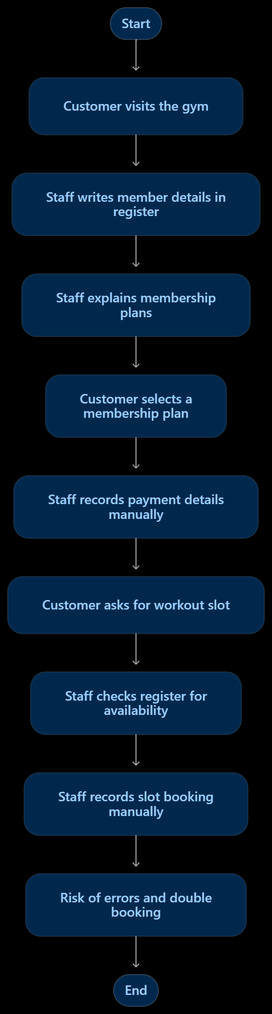
Problems in the AS-IS Workflow
- Member records are maintained manually.
- Finding or updating member information can take time.
- Tracking membership start and expiry dates may be difficult.
Staff must check slot availability manually.
- Incorrect entries or double bookings may occur.
- Preparing payment and booking reports can take extra effort.
3. TO-BE Workflow (Proposed System)
The TO-BE workflow represents the proposed web-based system. Member details and membership records are stored digitally. Payment status is recorded in the system, and available workout slots are shown to the customer. The system checks slot availability and capacity before confirming a booking. The initial version records payment status; it does not include an online payment gateway.
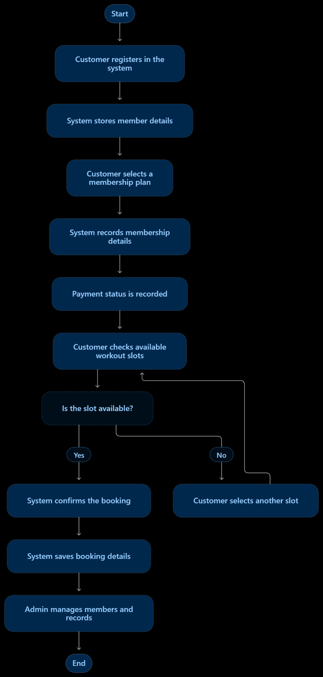
Benefits of the TO-BE Workflow
- Member and membership details are stored digitally.
- Membership start and expiry dates are easier to track.
- Payment status can be checked from stored records.
- The system checks slot capacity before confirming bookings.
- The system helps prevent bookings beyond the allowed capacity.
- Admin can manage records more efficiently.

